**RAD Online Shopping portal**



**Session: 2020**

**Submitted by:**

**Huma Javed 2020-SE-17**

**Anser Abbas 2020-SE-19**

**Muhammad Junaid 2020-SE-20**

**Submitted to:**

**Mr. Zeeshan Ramzan**

Department of Computer Science, New Campus **University of Engineering and Technology Lahore, Pakistan**

Table of Contents

Chapter 1: Introduction 4

Project Description: 4

Scope: 4

Vision: 4

Work Break Down Structure: 5

Timeline/ Gantt Chart: 6

Chapter 2: Requirements 7

1. Functional requirements: 7

2. Business requirements: 7

3. Business rules: 8

4. User requirements: 8

5. Non-functional requirements: 9

6. External interfaces: 10

7. Physical product Requirements: 10

8. Development constraints 11

9. Wireframes: 12

10. High Level and Low Level Story Boards: 20

Chapter 3: Design 21

1. Class Diagram: 21

2. Use Case Diagram (with detailed use cases): 22

3. Object Diagram: 31

4. Package Diagram: 32

5. Sequence Diagrams: 33

6. Collaboration Diagrams: 38

7. Deployment Diagram: 43

8. Component Diagram: 45

9. Activity Diagrams: 47

10. State chart Diagrams: 52

Chapter 4: Testing 57

Test Cases: 57

1.Unit Testing……………………………………………………………………………………………….57

2.Integration Testing………………………………………………………………………………………..61

3.System Testing……………………………………………………………………………………………62

4.Acceptance Testing……………………………………………………………………………………….66

5.Performace Testing……………………………………………………………………………………….71

6.Endurance Testing………………………………………………………………………………………..72

7.Spike Testing……………………………………………………………………………………………73

8.Security Testing…………………………………………………………………………………………73

9.Usability Testing…………………………………………………………………………………………75

10.Compatibility Testing……………………………………………………………………………………76

Chapter 5: User Interface 77

Screenshots of the software: 77

# **Chapter 1: Introduction**

# **Project Description:**

We are designing the shopping system. The system allows user to sign-in their account with unique ID and password. The system also allows user to create new account with new unique ID. After sign-in successfully the user buy different items. The admin manages the items quantity, add and remove different items. The customer watches the list of items which he adds into the cart. The customer also able to watch the prices of each item. Account owns customer orders. Customer may have no orders. Customer orders are sorted and unique. Each order could refer to several **payments**, possibly none. Every payment has unique id and is related to exactly one account. Customer have different options to pay the bill. The admin manages the payment and orders.

# **Scope:**

Our system provides an online shopping portal. A customer can choose different items. Customer can login to our system by his account then user can also contact with us by sending feedback. The admin can update the categories and products, etc. and also verifies the customer details.

# **Vision:**

The vision of this project is to design an online shopping portal. Customer login into the system and buy items.

# 

# **Work Break Down Structure**:



# 

# **Timeline/ Gantt Chart:**

|  |  |  |  |  |
| --- | --- | --- | --- | --- |
| Steps | First Week  (16 May 2021 to 22 May 2021) | Second Week  (24 May 2021 to 31 May 2021) | Third Week  (1 June 2021 to 8 June 2021) | Fourth Week  (9 June 2021 to 15 June 2021) |
| Scope, Vision of the Project |  |  |  |  |
| Requirements of the project |  |  |  |  |
| Story Boards of the Project |  |  |  |  |
| Use Cases |  |  |  |  |
| UML Diagrams of the Project |  |  |  |  |
| Test Cases |  |  |  |  |
| Building of the Prototype |  |  |  |  |

# 

# **Chapter 2: Requirements**

# **Functional requirements:**

• On the store, user would be able to view their favourite clothing from the brand without having to sign in.

• To add anything to the cart, the user will have to log into their account.

• A new user will be able to create their account or could connect their google or twitter account to the store.

The user will be able to change the password to their account. The user will be able to recover the password to their account in case forgotten.

• The user will be able to remove the items from their carts, change the quantity of the products added and apply discount codes.

• The user will be able to look at the sizing charts for the different products.

• The user will be able to select between the different sizes available for the selected product i.e., XS, S, M, L, XL.

• The admin will be able to update/edit the listings for the different products.

• The admin will be able to update/edit the personal information of the users.

• The admin will be able to upload the listings for new products.

• The admin will be able to recover the passwords for the users account on request.

# **Business requirements:**

The business requirement of the website are:

* Banks will be involved for the online payment.
* Confidential Information of the Customer and the Caption cannot be shared to the third party.

# **Business rules**:

The business rules of the website are given below:

* Only the admin will have allowed to change the items.
* Customer have an account for the online payment of the shopping.
* Our company shall follow the rules of the government tax.

# **User requirements**:

• New Customers or Visitors to the portal should be able to register their Accounts with our portal easily by themselves. Users will be differentiated by Unique user identifiers or email addresses.

• Payment Transactions would be secure. A simple or effective authentication mechanism should be used into our portal to prevent unauthorized customers from making transactions on a user’s behalf.

• Site visitors should be able to purchase goods or services in a simpler way.

• Users should be able to view a complete list of specified items available to purchase through the portal.

• Users should be able to view and select products of their interest and add them to their shopping carts for future reference to purchase later.

• Users should be able to view the delivery status of products they have ordered.

• Large number of users should be able to use our portal for shopping simultaneously.

# **Non-functional requirements:**

• **Security:**

Our store must maintain its security by keeping the credentials and private information of the users secure through two step verification and user authentication. The personal data of the users must be encrypted so that no one except the admin could access it.

• **Ease of use:**

1. All the requirements shall be according to user.
2. Menu items shall have names that are self-explanatory.
3. Place holders shall be available for the user.
4. The form provided to the user shall be easy to fill as only the necessary and basic information shall be asked.

• **Availability:**

Our store must be available 24/7 by ensuring internet availability and other essentials.

• **Maintainability:**

Our store must be regularly maintained and modified to fix the bugs and issues by adding new features and functions to the interface.

If any error occurs, system must be able to show the error to admin so that it can be fixed.

• **Scalability:**

Our store must be capable of supporting the changing requirements whether that’s in the form of new customers or a large form of data.

• **Responsiveness:**

1. The system must response within 3 seconds to any of the user’s request.
2. Form must be shown to user within 2 seconds.
3. Submitted form must be received by admin within 5 seconds.
4. Product must be sent to cart in 1 second.
5. User must receive confirmation email within half an hour.

• **Compatibility:**

Our system must be compatible with all the devices i.e., computers, mobile phones, laptops etc.

# **External interfaces:**

The external interface of the website are given below:

* This software would be able to run on every kind of the devices such as laptop, PC, mobile phones and I-pad.
* The communication protocol between the customer and the admin must be internet.

# Internet shall be available every time so that the customer can get the response in time.

# **Physical product Requirements:**

The physical product requirements of the website are given below:

* The electrical generator is must for the system to have the ability to always have the power supply, If the system is on the desktop.

# 

# **Development constraints:**

The Development constraints of the website are given below:

* When the customer Want to buy any product, he/she needs internet access to get access on the website.
* Customer and the caption are become upset when the software is not easy to use.
* Customer cannot face the difficulty after buying the product or waste time searching through the websites.
* We can use the unlimited disk space and the bandwidth.
* It shall contain the 1000 email address and the passwords.
* Customer purchase products according to his budget.
* It shall have the option to match with the customer requirements.

# 

# **Wireframes:**

**Login page:**

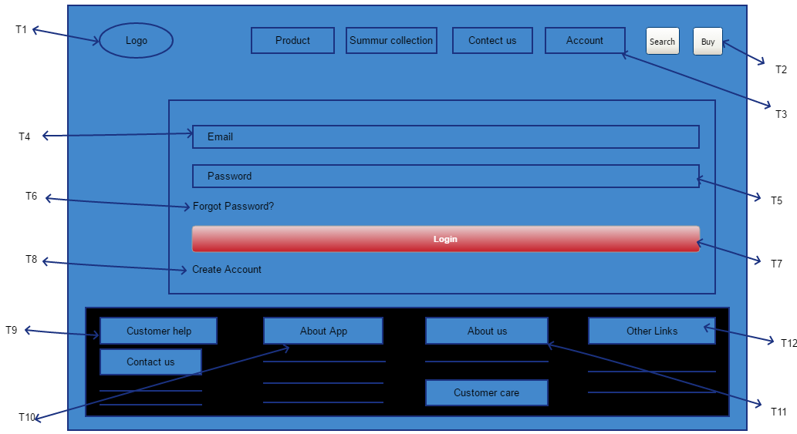

**Requirements:**

|  |  |  |
| --- | --- | --- |
|  | **User** | **Admin** |
| **T1** | As a user, I shall move on the main page by clicking on it. | As an admin, I shall modify, update its functionality and the logo. |
| **T2** | As a user, I shall search about any query. I shall also search about any product. | As an admin, I shall provide the searched content to the user. I shall provide the content to the user according to its requirements. |
| **T3** | As a user, I shall select the category to which related I want to see the stuff. | As an admin, I shall show the specific category products to the user. |
| **T4** | As a user, I shall enter email for login. | As an admin, I shall manage mange for the user to enter email. |
| **T5** | As a user, I shall enter password for login. | As an admin, I s0hall manage for the user to enter password. |
| **T6** | As a user, I shall be able to recover my password after clicking on this link. | As an admin, I shall be able to verify the user, edit the previous forgotten password. |
| **T7** | As a user, I shall be able to login my account after clicking the button. | As an admin, I shall be able to match the details entered by the user to the correct ones and grant them access to their account. |
| **T8** | As a user, I shall be able to create my new account. | As an admin, I shall mange for the user to create its new account. |
| **T9** | As a user, I shall able to contact the customer support through this tab | As an admin, I shall able to resolve the problems of the users by directing them to the customer support representatives and keep the records of the problems of the user |
| **T10** | As a user, I shall to see the details about app. | As an admin, I shall manage the details about app. |
| **T11** | As a user, I shall able to learn more about the company through this tab | As an admin, I shall able to update the history and achievements of the company |
| **T12** | As a user, I shall able to see the different links of other apps. | As an admin, I shall mange links of different app. |

**Contact Us page:**

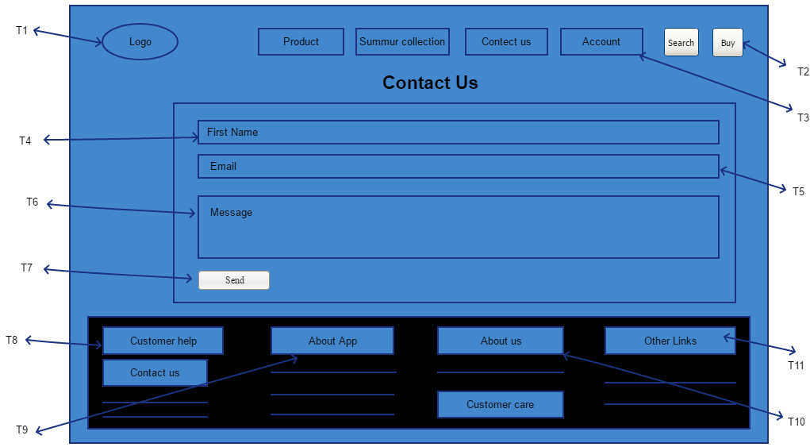

**Requirements:**

|  |  |  |
| --- | --- | --- |
|  | **User** | **Admin** |
| **T1** | As a user, I shall move on the main page by clicking on it. | As an admin, I shall modify, update its functionality and the logo. |
| **T2** | As a user, I shall search about any query. I shall also search about any product. | As an admin, I shall provide the searched content to the user. I shall provide the content to the user according to its requirements. |
| **T3** | As a user, I shall select the category to which related I want to see the stuff. | As an admin, I shall show the specific category products to the user. |
| **T4** | As a user, I shall able to enter my first name to contact with the company. | As an admin, I shall mange for the user to enter his first name to contact with the company. |
| **T5** | As a user, I shall enter email to contact with the company. | As an admin, I shall manage mange for the user to enter email to contact with the company. |
| **T6** | As a user, I shall be able to write a comment or feedback. | As an admin, I shall mange for the user to write a comment or feedback. |
| **T7** | As a user, I shall be able to send my feedback by clicking on it. | As an admin, I shall mange for the user to send feedback by clicking on it. |
| **T8** | As a user, I shall able to contact the customer support through this tab | As an admin, I shall able to resolve the problems of the users by directing them to the customer support representatives and keep the records of the problems of the user |
| **T9** | As a user, I shall to see the details about app. | As an admin, I shall manage the details about app. |
| **T10** | As a user, I shall able to learn more about the company through this tab | As an admin, I shall able to update the history and achievements of the company |
| **T11** | As a user, I shall able to see the different links of other apps. | As an admin, I shall mange links of different app. |

**Summer Collection:**

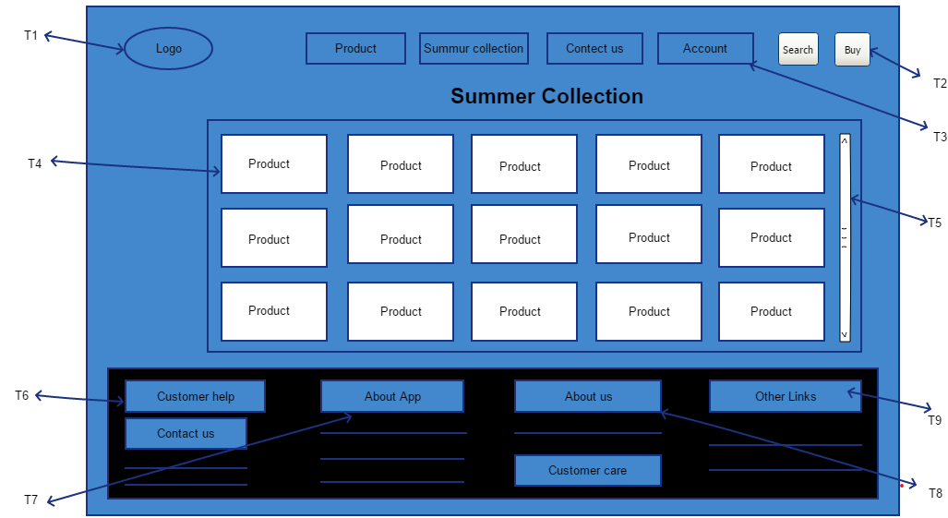

**Requirements:**

|  |  |  |
| --- | --- | --- |
|  | **User** | **Admin** |
| **T1** | As a user, I shall move on the main page by clicking on it. | As an admin, I shall modify, update its functionality and the logo. |
| **T2** | As a user, I shall search about any query. I shall also search about any product. | As an555 admin, I shall provide the searched content to the user. I shall provide the content to the user according to its requirements. |
| **T3** | As a user, I shall select the category to which related I want to see the stuff. | As an admin, I shall show the specific category products to the user. |
| **T4** | As a user, I shall able to see the products. | As an admin, I shall able to add, remove the products. |
| **T5** | As a user, I shall able to scroll the products. | As an admin, I shall mange for the user to scroll the products. |
| **T6** | As a user, I shall to see the details about app. | As an admin, I shall manage the details about app. |
| **T7** | As a user, I shall able to learn more about the company through this tab | As an admin, I shall able to update the history and achievements of the company |
| **T8** | As a user, I shall able to see the different links of other apps. | As an admin, I shall mange links of different app. |

**Product page:**

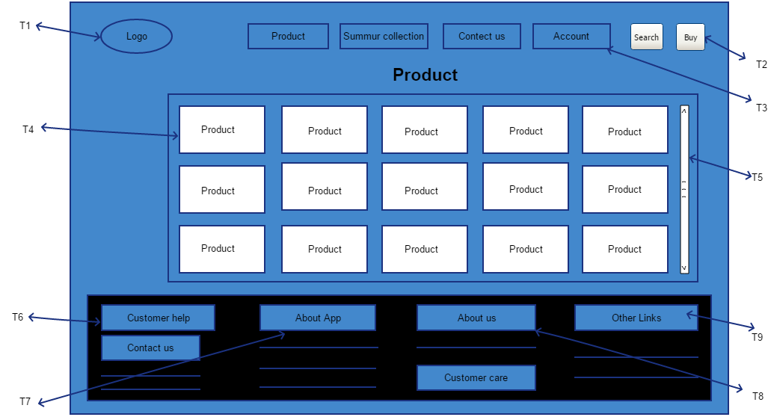

**Requirements:**

|  |  |  |
| --- | --- | --- |
|  | **User** | **Admin** |
| **T1** | As a user, I shall move on the main page by clicking on it. | As an admin, I shall modify, update its functionality and the logo. |
| **T2** | As a user, I shall search about any query. I shall also search about any product. | As an admin, I shall provide the searched content to the user. I shall provide the content to the user according to its requirements. |
| **T3** | As a user, I shall select the category to which related I want to see the stuff. | As an admin, I shall show the specific category products to the user. |
| **T4** | As a user, I shall able to see the products. | As an admin, I shall able to add, remove the products. |
| **T5** | As a user, I shall able to scroll the products. | As an admin, I shall mange for the user to scroll the products. |
| **T6** | As a user, I shall to see the details about app. | As an admin, I shall manage the details about app. |
| **T7** | As a user, I shall able to learn more about the company through this tab | As an admin, I shall able to update the history and achievements of the company |
| **T8** | As a user, I shall able to see the different links of other apps. | As an admin, I shall mange links of different app. |

**Create Account page:**

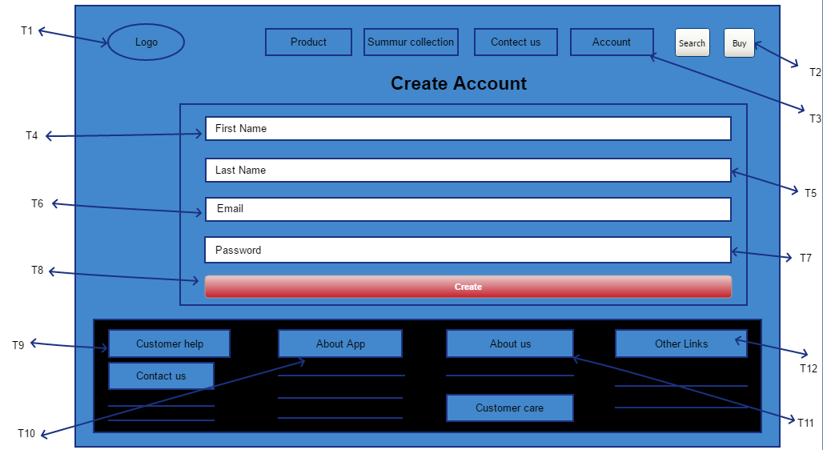**Requirements:**

|  |  |  |
| --- | --- | --- |
|  | **User** | **Admin** |
| **T1** | As a user, I shall move on the main page by clicking on it. | As an admin, I shall modify, update its functionality and the logo. |
| **T2** | As a user, I shall search about any query. I shall also search about any product. | As an admin, I shall provide the searched content to the user. I shall provide the content to the user according to its requirements. |
| **T3** | As a user, I shall select the category to which related I want to see the stuff. | As an admin, I shall show the specific category products to the user. |
| **T4** | As a user, I shall able to enter my first name for my new account. | As a admin, I shall mange for the user to enter his first name for his new account. |
| **T5** | As a user, I shall able to enter my last name for my new account. | As an admin, I shall mange for the user to enter his last name for his new account. |
| **T6** | As a user, I shall able to enter email for my new account. | As an admin, I shall mange for the user to enter email for his new account. |
| **T7** | As a user, I shall able to enter password for my new account. | As an admin, I shall manage for the user to enter password for his new account. |
| **T8** | As a user, I shall be able to create my new account by clicking on it. | As an admin, I shall mange for the user to create his new account. |
| **T9** | As a user, I shall able to contact the customer support through this tab | As an admin, I shall able to resolve the problems of the users by directing them to the customer support representatives and keep the records of the problems of the user |
| **T10** | As a user, I shall to see the details about app. | As an admin, I shall manage the details about app. |
| **T11** | As a user, I shall able to learn more about the company through this tab | As an admin, I shall able to update the history and achievements of the company |
| **T12** | As a user, I shall able to see the different links of other apps. | As an admin, I shall mange links of different app. |

# 

# **High Level and Low-Level Story Boards:**

**High level story boarding:**

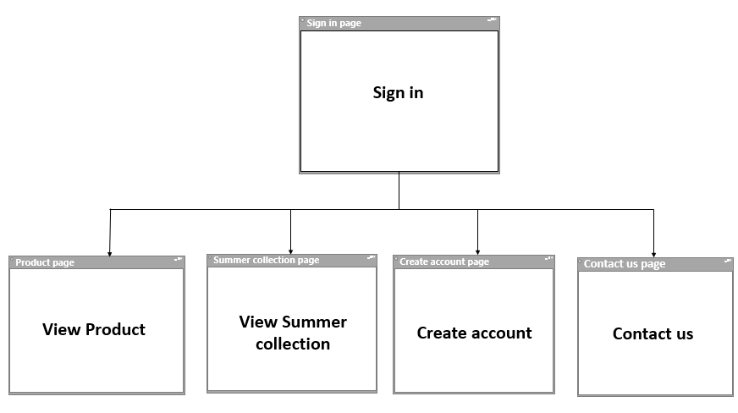

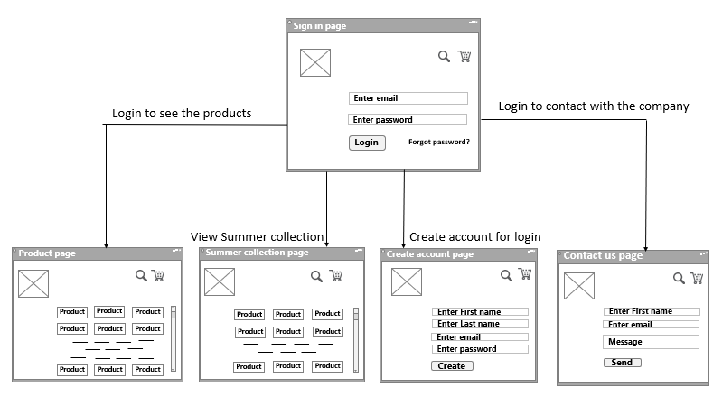**Low level story boarding:**

# **Chapter 3: Design**

# **Class Diagram:**

# **Use Case Diagram (with detailed use cases):**

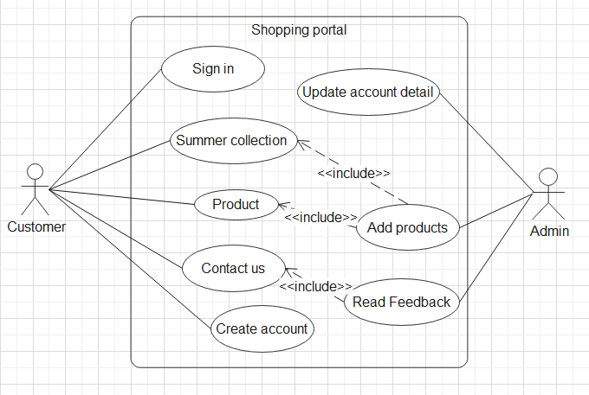

**Use cases**

**Sign in use case:**

|  |  |
| --- | --- |
| **Name** | Sign in page |
| **Participating actors** | Customer. |
| **Goals** | Login to the system. |
| **Triggers** | Open the web site. |
| **Pre-condition** | Enter e-mail and password. |
| **Post-condition** | Sign in to system and get information. |
| **Basic flow** | Open sign in page and enter his/her email and password then login to the system. |
| **Alternate flow** | In case of wrong email or password customer shall reset password. |
| **Exception** | Customer know the password. |
| **Qualities** | * Login page appear on screen. * Within seconds login to the system when customer pressed login. |

**Contact Us use case:**

|  |  |
| --- | --- |
| **Name** | Contact us page |
| **Participating actors** | Customer. |
| **Goals** | Contact with the admin |
| **Triggers** | Login to the system |
| **Pre-condition** | Enter first name, email and feedback. |
| **Post-condition** | Feedback is send. |
| **Basic flow** | Open contact us page and enter his/her email and first name and feedback and click on send. |
| **Alternate flow** | User can also contact by the phone number. |
| **Exception** | Customer no need to contact. |
| **Qualities** | Feedback send within send. |

**Summer Collection use case:**

|  |  |
| --- | --- |
| **Name** | Summer collection page |
| **Participating actors** | Customer. |
| **Goals** | See the summer collection. |
| **Triggers** | Login to the system |
| **Pre-condition** | Open the summer collection page. |
| **Post-condition** | Customer can see the product. |
| **Basic flow** | Login to the system then click on summer collection page and see the product. |
| **Alternate flow** | User personally visit the shop to buy cloths. |
| **Exception** | Customer no need to purchase the cloths |
| **Qualities** | Customer can see the products and all its details. |

**Product use case:**

|  |  |
| --- | --- |
| **Name** | Product page |
| **Participating actors** | Customer. |
| **Goals** | See the products of different brand |
| **Triggers** | Login to the system |
| **Pre-condition** | Open the product page |
| **Post-condition** | Customer can see the products. |
| **Basic flow** | Login to the system then click on product page and see the product. |
| **Alternate flow** | User personally visit the shop to buy cloths. |
| **Exception** | Customer no need to purchase the cloths |
| **Qualities** | Customer can see the products and all its details. |

**Create Account use case:**

|  |  |
| --- | --- |
| **Name** | Create account page |
| **Participating actors** | Customer. |
| **Goals** | Create a new account |
| **Triggers** | Login to the system |
| **Pre-condition** | Enter the first name, last name, email and password. |
| **Post-condition** | Customer account is created. |
| **Basic flow** | Login to the system enter first name last name email and password and click on create |
| **Alternate flow** | No alternative flow. |
| **Exception** | User have an account |
| **Qualities** | User account is created within second whenever he clicked on create button. |

**Update account use case:**

|  |  |
| --- | --- |
| **Name** | Update account detail. |
| **Participating actors** | Admin. |
| **Goals** | Updating detail of account. |
| **Triggers** | Customer request to update the account. |
| **Pre-condition** | Customer has an account and wants to update it. |
| **Post-condition** | Account is successfully updated. |
| **Basic flow** | Admin sign in to the account and accept the update request and then update his/her account. |
| **Alternate flow** | Not available. |
| **Exception** | Error occur in update account page. |
| **Qualities** | Account detail update within seconds. |

**Add product use case:**

|  |  |
| --- | --- |
| **Name** | Add product |
| **Participating actors** | Admin. |
| **Goals** | Add product in the system. |
| **Triggers** | Login to the system. |
| **Pre-condition** | Select the product which wants to add. |
| **Post-condition** | Product is added. |
| **Basic flow** | Admin sign in to the account and open the product page then select the product which wants add and then click on add button. |
| **Alternate flow** | Admin personally visit the shop and add different products. |
| **Exception** | Products stock is full. |
| **Qualities** | Product is added in the system within few seconds. |

**Feedback use case:**

|  |  |
| --- | --- |
| **Name** | Read Feedback |
| **Participating actors** | Admin |
| **Goals** | Feedback send to admin |
| **Triggers** | Login to the system. |
| **Pre-condition** | Feedback is reached to the admin. |
| **Post-condition** | Feedback is read. |
| **Basic flow** | Feedback is sent to the company and it is read by company |
| **Alternate flow** | Not available |
| **Exception** | No feedback is reached. |
| **Qualities** | Feedback read within seconds. |

# **Object Diagram:**



# 

# **Package Diagram:**



# 

# **Sequence Diagrams**:

**Login page:**



**Add items into cart:**



**Order & Payment:**



**Add, Remove and Modify Items:**

**View order and payments:**



# **Collaboration Diagrams:**

**Login page**



**Add into Cart**



**Order item**



**Add, Remove & Modify Items**



**View Order**



# **Deployment Diagram:**

**NO 1:**

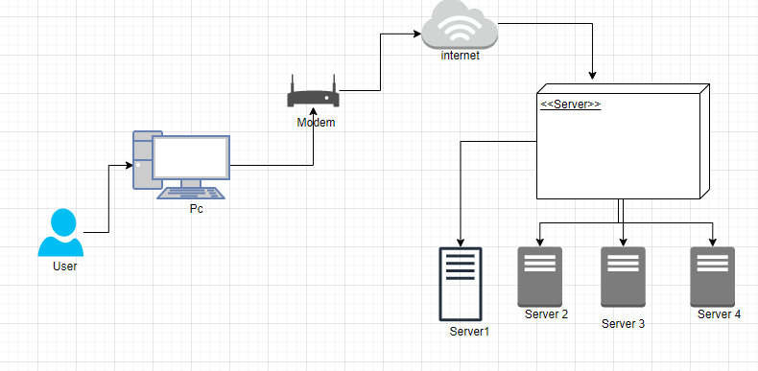

**NO 2**

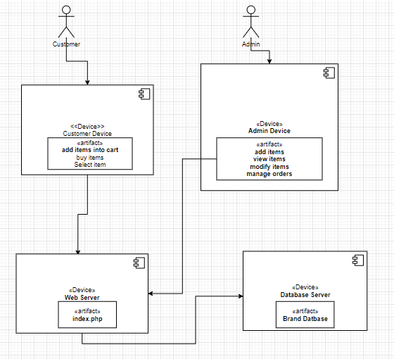

# 

# **Component Diagram:**

**Admin End**

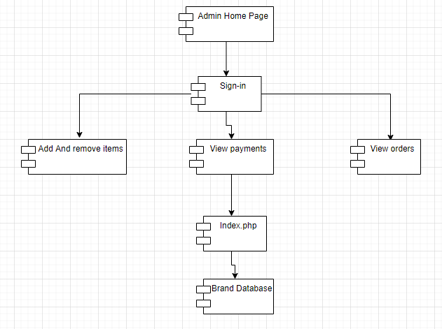

**Customer End**

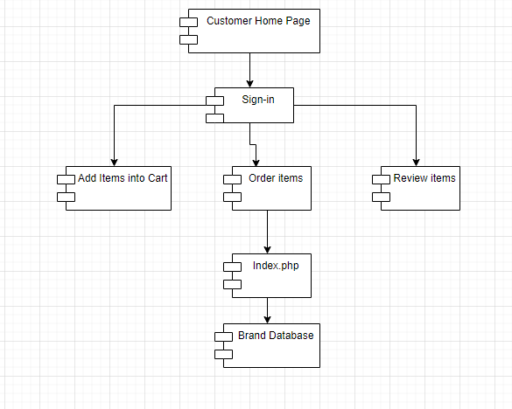

# 

# **Activity Diagrams:**

**Login page**



**Add into Cart**



**Order items**



**Add, Remove & Modify item**



**View Order**



# **State chart Diagrams:**

**Login page**



**Add item into Cart**



**Order item**



**Add, Remove & Modify Items**



**View Order**



# 

# **Chapter 4: Testing**

# **Test Cases:**

**Testing**

**Unit testing:**

In unit testing, the testing of each component is performed. It is starting level testing which involves the testing of individual unit of software. Unit testing is performed to validate whether each component is working properly or not.

**Login page testing**

**Enter email:**

The component Enter email is used to enter email for login to the system.

|  |  |  |  |
| --- | --- | --- | --- |
| Sr. | **Test data** | **Expected result** | **Test result** |
| 1. | Enter the email | Email is entered to the system. | Successful |

**Enter password:**

The component Enter password is used to enter password for login to the system.

|  |  |  |  |
| --- | --- | --- | --- |
| Sr. | **Test data** | **Expected result** | **Test result** |
| 1. | Enter the password | Password is entered to the system. | Successful |

**Login button:**

The component login button is used to login to the system when it is clicked.

|  |  |  |  |
| --- | --- | --- | --- |
| Sr. | **Test data** | **Expected result** | **Test result** |
| 1. | Click on login button. | Login details are verified and then login to the system. | Successful |

**Contact us screen testing**

**Enter first name:**

The component first name is used to enter name of user to send feedback.

|  |  |  |  |
| --- | --- | --- | --- |
| Sr. | **Test data** | **Expected result** | **Test result** |
| 1. | Enter first name | First name is entered to the system. | Successful |

**Enter email:**

The component Enter email is used to enter email of user to send feedback

|  |  |  |  |
| --- | --- | --- | --- |
| Sr. | **Test data** | **Expected result** | **Test result** |
| 1. | Enter the email | Email is entered to the system. | Successful |

**Enter message:**

The component message is used to write a feedback of the product.

|  |  |  |  |
| --- | --- | --- | --- |
| Sr. | **Test data** | **Expected result** | **Test result** |
| 1. | Enter massage | Feedback is entered to the system. | Successful |

**Send button:**

The component send button is used to send feedback to the company when it is clicked.

|  |  |  |  |
| --- | --- | --- | --- |
| Sr. | **Test data** | **Expected result** | **Test result** |
| 1. | Click on send button. | Feedback is sent to company. | Successful |

**Product Screen Testing**

**Product:**

The component product is used to see the product which are added by the admin.

|  |  |  |  |
| --- | --- | --- | --- |
| Sr. | **Test data** | **Expected result** | **Test result** |
| 1. | View product. | Added product are viewed | Successful |

**Add cart:**

The component add cart is used to store items that user buy or wants to buy.

|  |  |  |  |
| --- | --- | --- | --- |
| Sr. | **Test data** | **Expected result** | **Test result** |
| 1 | Click on the item | Confirmation page appears | Successful |
| 2. | Click on add cart or buy no | Add into the cart. | Successful |

**Summer Collection Screen Testing**

**Product:**

The component product is used to see the summer collection which are added by the admin.

|  |  |  |  |
| --- | --- | --- | --- |
| Sr. | **Test data** | **Expected result** | **Test result** |
| 1. | View summer collection. | Added summer collection are viewed | Successful |

**Add cart:**

The component add cart is used to store items that user buy or wants to buy.

|  |  |  |  |
| --- | --- | --- | --- |
| Sr. | **Test data** | **Expected result** | **Test result** |
| 1 | Click on the item | Confirmation page appears | Successful |
| 2. | Click on add cart or buy no | Add into the cart. | Successful |

**Create account screen testing**

**Enter first name:**

The component first name is used to enter name of user for create an account of user.

|  |  |  |  |
| --- | --- | --- | --- |
| Sr. | **Test data** | **Expected result** | **Test result** |
| 1. | Enter first name | First name is entered to the system. | Successful |

**Enter last name:**

The component last name is used to enter last name of user for create an account of user.

|  |  |  |  |
| --- | --- | --- | --- |
| Sr. | **Test data** | **Expected result** | **Test result** |
| 1. | Enter last name | Last name is entered to the system. | Successful |

**Enter email:**

The component Enter email is used to enter email to create an account of user.

|  |  |  |  |
| --- | --- | --- | --- |
| Sr. | **Test data** | **Expected result** | **Test result** |
| 1. | Enter the email | Email is entered to the system. | Successful |

**Enter password:**

The component Enter password is used to enter password to create an account of user

|  |  |  |  |
| --- | --- | --- | --- |
| Sr. | **Test data** | **Expected result** | **Test result** |
| 1. | Enter the password | Password is entered to the system. | Successful |

**Create button:**

The component create button is used to create an account of user when it is clicked.

|  |  |  |  |
| --- | --- | --- | --- |
| Sr. | **Test data** | **Expected result** | **Test result** |
| 1. | Click on create button. | Account is created. | Successful |

**Integration testing**

After each unit is thoroughly tested, it is integrated with other units to create modules or components that are designed to perform specific tasks or activities. These are then tested as group through integration testing to ensure whole segments of an application behave as expected.

**Login testing screen:**

User able to sign in to the system.

|  |  |  |  |  |
| --- | --- | --- | --- | --- |
| Sr. | **Test data** | **Expected result** | **Test result** | **Pass/fail** |
| 1. | User enter email or password and click on login | User able to login to the system. | User login to the system | Pass |
| 2. | User not exist | User not able to login. | User is not signed in. | Pass |

**Contact us testing screen:**

User able to contact to the company.

|  |  |  |  |  |
| --- | --- | --- | --- | --- |
| Sr. | **Test data** | **Expected result** | **Test result** | **Pass/fail** |
| 1. | User enter first name, email and feedback and then click on login. | User able to send message. | User send feedback to the company | Pass |
| 2. | User not exist | User not able to send message | User does not send feedback | Pass |

**Product testing screen:**

User able to viewed the product.

|  |  |  |  |  |
| --- | --- | --- | --- | --- |
| Sr. | **Test data** | **Expected result** | **Test result** | **Pass/fail** |
| 1. | Product are viewed which are added by the admin. | User able to view the product. | User view the products. | Pass |
| 2. | User not exist | User not able to view the product. | User does not see the products. | Pass |

**Summer collection testing screen:**

User able to viewed the summer collection.

|  |  |  |  |  |
| --- | --- | --- | --- | --- |
| Sr. | **Test data** | **Expected result** | **Test result** | **Pass/fail** |
| 1. | Collection is viewed which are added by the admin. | User able to view the summer collection. | User view the summer collection. | Pass |
| 2. | User not exist | User not able to view the summer collection | User does not see the summer collection. | Pass |

**Create account testing screen:**

User able to create its account.

|  |  |  |  |  |
| --- | --- | --- | --- | --- |
| Sr. | **Test data** | **Expected result** | **Test result** | **Pass/fail** |
| 1. | User enter first name, last name, email and password and then click on create. | User able to create its account. | User create its account. | Pass |
| 2. | User not exist | User not able to create account. | User does not able to create account. | Pass |

**System Testing**

System testing is a black box testing method used to evaluate the completed and integrated system, as a whole, to ensure it meets specified requirements. The functionality of the software is tested from end-to-end.

**Create new account testing**

|  |  |  |  |  |  |
| --- | --- | --- | --- | --- | --- |
| **Test Case ID** | ID 001 | **Test Case Description** | Create New Account | |  |
| **Created By** | M. Junaid | **Reviewed By** | Huma Javed | **Version** | 1.0.1 |

|  |  |  |  |  |  |
| --- | --- | --- | --- | --- | --- |
| **Tester Name** | Anser Abbas | **Date Tested** | 16-4-2021 | **Test case (Pass/fail/not executed)** | Pass |

|  |  |
| --- | --- |
| **S#** | **Pre-requisites** |
| 1 | Have internet connection |

|  |
| --- |
| **Test scenario** |

Verify user able to create new account.

|  |  |  |  |  |
| --- | --- | --- | --- | --- |
| **Step #** | **Step Details** | **Expected Results** | **Actual Results** | **Pass/Fail/Not executed/Suspended** |
|  |  |  |  |  |
| 1 | Click create account button | Create account screen shown | As Expected, | Pass |
| 2 | Enter name, email and password | Credentials entered into the system | As Expected, | Pass |
| 3 | Click create account | Account created successfully | As Expected, | Pass |

**Post Condition**  User logged in into the system and able to search services

. **Login Screen Testing**

|  |  |  |  |  |  |
| --- | --- | --- | --- | --- | --- |
| **Test Case ID** | ID 002 | **Test Case Description** | Login Account | |  |
| **Created By** | Anser Abbas | **Reviewed By** | Huma Javed | **Version** | 1.0.1 |

|  |  |  |  |  |  |
| --- | --- | --- | --- | --- | --- |
| **Tester Name** | Anser Abbas | **Date Tested** | 16-4-2021 | **Test case (Pass/fail/not executed)** | Pass |

|  |  |
| --- | --- |
| **S#** | **Pre-requisites** |
| 1 | Have internet connection |
| 2 | Must have an account |

|  |
| --- |
| **Test scenario** |

Verify user able to sign in into the system.

|  |  |  |  |  |
| --- | --- | --- | --- | --- |
| **Step #** | **Step Details** | **Expected Results** | **Actual Results** | **Pass/Fail/Not executed/Suspended** |
| 1 | Enter email and password. | Credentials entered into the system | As Expected, | Pass |
| 2 | Click sign-in | Logged into the system | As Expected, | Pass |

**Post Condition**  User logged in into the system and able to search services.

**Contact us Screen testing:**

|  |  |  |  |  |  |
| --- | --- | --- | --- | --- | --- |
| **Test Case ID** | ID 003 | **Test Case Description** | Contact us | |  |
| **Created By** | M. Junaid | **Reviewed By** | Huma Javed | **Version** | 1.0.3 |

|  |  |  |  |  |  |
| --- | --- | --- | --- | --- | --- |
| **Tester Name** | Anser Abbas | **Date Tested** | 14-6-2021 | **Test case (Pass/fail/not executed)** | Pass |

|  |  |
| --- | --- |
| **S#** | **Pre-requisites** |
| 1 | Have internet connection |
| 2 | Must have an account |

|  |
| --- |
| **Test scenario** |

Verify user able to sign in into the system.

|  |  |  |  |  |
| --- | --- | --- | --- | --- |
| **Step #** | **Step Details** | **Expected Results** | **Actual Results** | **Pass/Fail/Not executed/Suspended** |
| 1 | Enter name, email and Message. | Credentials entered into the system | As Expected, | Pass |
| 2 | Click send. | Credentials entered into the system | As Expected, | Pass |

**Post Condition**  User logged in into the system and able to search services.

**Product screen Testing**

|  |  |  |  |  |  |  |
| --- | --- | --- | --- | --- | --- | --- |
| **Test Case ID** | ID 004 | **Test Case Description** | Product screen |  | | |
| **Created By** | M. Junaid | **Reviewed By** | Huma Javed | | **Version** | 1.0.4 |

|  |  |  |  |  |  |
| --- | --- | --- | --- | --- | --- |
| **Tester Name** | Anser Abbas | **Date Tested** | 14-06-2021 | **Test case (Pass/fail/not executed)** | Pass |

|  |  |
| --- | --- |
| **S#** | **Pre-requisites** |
| 1 | Have internet connection |
| 2 | Must have an account |

|  |
| --- |
| **Test scenario** |

Verify user able to sign in into the system.

|  |  |  |  |  |
| --- | --- | --- | --- | --- |
| **Step #** | **Step Details** | **Expected Results** | **Actual Results** | **Pass/Fail/Not executed/Suspended** |
| 1 | Customer click, on the product. | Credentials entered into the system | As Expected, | Pass |
| 2 | Click buy or add cart. | Credentials entered into the system | As Expected, | Pass |

**Post Condition**  User logged in into the system and able to search services.

**Summer collection screen testing**

|  |  |  |  |  |  |
| --- | --- | --- | --- | --- | --- |
| **Test Case ID** | ID 003 | **Test Case Description** | Summer Collection | |  |
| **Created By** | M. Junaid | **Reviewed By** | Huma Javed | **Version** | 1.0.3 |

|  |  |  |  |  |  |
| --- | --- | --- | --- | --- | --- |
| **Tester Name** | Anser Abbas | **Date Tested** | 14-6-2021 | **Test case (Pass/fail/not executed)** | pass |

|  |  |
| --- | --- |
| **S#** | **Pre-requisites** |
| 1 | Have internet connection |
| 2 | Must have an account |

|  |
| --- |
| **Test scenario** |

Verify user able to sign in into the system.

|  |  |  |  |  |
| --- | --- | --- | --- | --- |
| **Step #** | **Step Details** | **Expected Results** | **Actual Results** | **Pass/Fail/Not executed/Suspended** |
| 1 | Click on the item. | Credentials entered into the system | As Expected, | Pass |
| 2 | Click add to cart or buy button. | Credentials entered into the system | As Expected, | Pass |

**Post Condition** User logged in into the system and able to search services.

**Acceptance Testing**

Acceptance testing is the last phase of functional testing and is used to assess whether or not the final piece of software is ready for delivery. It involves ensuring that the product is in compliance with all of the original business criteria and that it meets the end user ‘s needs. Acceptance testing is formal testing based on user requirements and function processing. It determines whether the software is conforming specified requirements and user requirements or not. It is conducted as a kind of Black Box testing where the number of required users involved testing the acceptance level of the system. This requires the product be tested both internally and externally, meaning you will need to get it into the hands of your end users for beta testing. Beta testing is key to getting real feedback from potential customers and can address any final usability concerns. However, the software has passed through three testing levels (Unit Testing, Integration Testing, System Testing) But still there are some minor errors which can be identified when the system is used by the end user in the actual scenario.

**Create new account testing**

|  |  |  |  |  |  |
| --- | --- | --- | --- | --- | --- |
| **Test Case ID** | ID 001 | **Test Case Description** | Create New Account | |  |
| **Created By** | M. Junaid | **Reviewed By** | Huma Javed | **Version** | 1.0.1 |

|  |  |  |  |  |  |
| --- | --- | --- | --- | --- | --- |
| **Tester Name** | Anser Abbas | **Date Tested** | 16-4-2021 | **Test case (Pass/fail/not executed)** | Pass |

|  |  |
| --- | --- |
| **S#** | **Pre-requisites** |
| 1 | Have internet connection |

|  |  |
| --- | --- |
| **S#** | **Test data** |
| **1** | Name =Ali |
| 2 | Email =asd@mail.com |
| 3 | Password =123as |

|  |
| --- |
| **Test scenario** |

Verify user able to create new account.

|  |  |  |  |  |
| --- | --- | --- | --- | --- |
| **Step #** | **Step Details** | **Expected Results** | **Actual Results** | **Pass/Fail/Not executed/Suspended** |
|  |  |  |  |  |
| 1 | Click create account button | Create account screen shown | As Expected, | Pass |
| 2 | Enter name, email and password | Credentials entered into the system | As Expected, | Pass |
| 3 | Click create account | Account created successfully | As Expected, | Pass |

**Post Condition**  User logged in into the system and able to search services

. **Login Screen Testing**

|  |  |  |  |  |  |
| --- | --- | --- | --- | --- | --- |
| **Test Case ID** | ID 002 | **Test Case Description** | Login Account | |  |
| **Created By** | Anser Abbas | **Reviewed By** | Huma Javed | **Version** | 1.0.1 |

|  |  |  |  |  |  |
| --- | --- | --- | --- | --- | --- |
| **Tester Name** | Anser Abbas | **Date Tested** | 16-4-2021 | **Test case (Pass/fail/not executed)** | Pass |

|  |  |
| --- | --- |
| **S#** | **Pre-requisites** |
| 1 | Have internet connection |
| 2 | Must have an account |

|  |  |
| --- | --- |
| **S#** | **Test data** |
| 1 | Email =asd@mail.com |
| 2 | Password =123as |

|  |
| --- |
| **Test scenario** |

Verify user able to sign in into the system.

|  |  |  |  |  |
| --- | --- | --- | --- | --- |
| **Step #** | **Step Details** | **Expected Results** | **Actual Results** | **Pass/Fail/Not executed/Suspended** |
| 1 | Enter email and password. | Credentials entered into the system | As Expected, | Pass |
| 2 | Click sign-in | Logged into the system | As Expected, | Pass |

**Post Condition**  User logged in into the system and able to search services.

**Contact us Screen testing:**

|  |  |  |  |  |  |
| --- | --- | --- | --- | --- | --- |
| **Test Case ID** | ID 003 | **Test Case Description** | Contact us | |  |
| **Created By** | M. Junaid | **Reviewed By** | Huma Javed | **Version** | 1.0.3 |

|  |  |  |  |  |  |
| --- | --- | --- | --- | --- | --- |
| **Tester Name** | Anser Abbas | **Date Tested** | 14-6-2021 | **Test case (Pass/fail/not executed)** | Pass |

|  |  |
| --- | --- |
| **S#** | **Pre-requisites** |
| 1 | Have internet connection |
| 2 | Must have an account |

|  |  |
| --- | --- |
| **S#** | **Test data** |
| 1 | Massage =This is so good website. |
| 2 | Massage =Very beautiful |

|  |
| --- |
| **Test scenario** |

Verify user able to sign in into the system.

|  |  |  |  |  |
| --- | --- | --- | --- | --- |
| **Step #** | **Step Details** | **Expected Results** | **Actual Results** | **Pass/Fail/Not executed/Suspended** |
| 1 | Enter name, email and Message. | Credentials entered into the system | As Expected, | Pass |
| 2 | Click send. | Credentials entered into the system | As Expected, | Pass |

**Post Condition**  User logged in into the system and able to search services.

**Product screen Testing**

|  |  |  |  |  |  |  |
| --- | --- | --- | --- | --- | --- | --- |
| **Test Case ID** | ID 004 | **Test Case Description** | Product screen |  | | |
| **Created By** | M. Junaid | **Reviewed By** | Huma Javed | | **Version** | 1.0.4 |

|  |  |  |  |  |  |
| --- | --- | --- | --- | --- | --- |
| **Tester Name** | Anser Abbas | **Date Tested** | 14-06-2021 | **Test case (Pass/fail/not executed)** | Pass |

|  |  |
| --- | --- |
| **S#** | **Pre-requisites** |
| 1 | Have internet connection |
| 2 | Must have an account |

|  |  |
| --- | --- |
| **S#** | **Test data** |
| 1 | View = |
| 2 | View = |

|  |
| --- |
| **Test scenario** |

Verify user able to sign in into the system.

|  |  |  |  |  |
| --- | --- | --- | --- | --- |
| **Step #** | **Step Details** | **Expected Results** | **Actual Results** | **Pass/Fail/Not executed/Suspended** |
| 1 | Customer click, on the product. | Credentials entered into the system | As Expected, | Pass |
| 2 | Click buy or add cart. | Credentials entered into the system | As Expected, | Pass |

**Post Condition**  User logged in into the system and able to search services.

**Summer collection screen testing**

|  |  |  |  |  |  |
| --- | --- | --- | --- | --- | --- |
| **Test Case ID** | ID 003 | **Test Case Description** | Summer Collection | |  |
| **Created By** | M. Junaid | **Reviewed By** | Huma Javed | **Version** | 1.0.3 |

|  |  |  |  |  |  |
| --- | --- | --- | --- | --- | --- |
| **Tester Name** | Anser Abbas | **Date Tested** | 14-6-2021 | **Test case (Pass/fail/not executed)** | pass |

|  |  |
| --- | --- |
| **S#** | **Pre-requisites** |
| 1 | Have internet connection |
| 2 | Must have an account |

|  |  |
| --- | --- |
| **S#** | **Test data** |
| 1 | View = |
| 2 | View = |

|  |
| --- |
| **Test scenario** |

Verify user able to sign in into the system.

|  |  |  |  |  |
| --- | --- | --- | --- | --- |
| **Step #** | **Step Details** | **Expected Results** | **Actual Results** | **Pass/Fail/Not executed/Suspended** |
| 1 | Click on the item. | Credentials entered into the system | As Expected, | Pass |
| 2 | Click add to cart or buy button. | Credentials entered into the system | As Expected, | Pass |

**Post Condition** User logged in into the system and able to search services.

**Performance Testing**

Performance testing is a non-functional testing technique used to determine how an application will behave under various conditions. The goal is to test its responsiveness and stability in real user situations.

**Load testing**

|  |  |  |
| --- | --- | --- |
| **Sr. no.** | **Functionality** | **Estimated Load Time (seconds)** |
| **1.** | Sign in | 0.2 to 0.5 |
| **2.** | Sign up | 0.2 to 0.5 |
| **3.** | Home | 0.1 to 0.3 |
| **4.** | List of products | 0.3 to 0.5 |
| **5.** | Search services | 1 to 3 |
| **6.** | View products | 0.1 to 0.3 |
| **7.** | Send massage | 0.2 to 0.5 |
| **8.** | Pay and Review | 2 to 5 |
| **9.** | About us | 0.1 to 0.3 |

**Stress testing**

|  |  |  |
| --- | --- | --- |
| **Sr. no.** | **Functionality** | **Estimated Load Time (seconds)** |
| **1.** | Sign in | 1 to 3 |
| **2.** | Sign up | 1 to 2 |
| **3.** | Home | 0.5 to 1 |
| **4.** | List of products | 1 to 2 |
| **5.** | Search services | 3 to 5 |
| **6.** | View products | 1 to 2 |
| **7.** | Send massage | 1 to 2 |
| **8.** | Pay and Review | 3 to 5 |
| **9.** | About us | 1 to 2 |

**Endurance Testing**

We done this testing under the heavy load of the data and putting that load Over a Longer amount of time to understand how your system will behave under sustained use, making it a longer process than load or stress testing.

|  |  |
| --- | --- |
| **Sr. no** | **Endurance Test** |
| **1.** | Complete many orders so system not able to handle as many orders. |
| **2.** | Send many messages so that system sustained to load messages |
| **3.** | Load many services so system cannot able to load properly. |
| **4.** | Request many booking so user cannot handle. |

**Spike Testing**

We done this testing under the heavy load of the data and putting that load of same amount of data over a longer amount of time to understand how your system will behave when the load is suddenly and drastically increase.

|  |  |
| --- | --- |
| **Sr. no** | **Spike Test** |
| **1.** | Enter many wrong email and passwords again and again. |
| **2.** | User send many requests to provider so create load on provider. |
| **3.** | Send thousands of messages to provider. |
| **4.** | Unable to handle multiple user requests. |

**Security Testing**

With the rise of cloud-based testing platforms and cyber-attacks, there is a growing concern and need for the security of data being used and stored in software. Security testing is a non-functional software testing technique used to determine if the information and data in a system is protected. The goal is to purposefully find loopholes and security risks in the system that could result in unauthorized access to or the loss of information by probing the application for weaknesses.

**Integrity:**

We managed integrity of our system by user access controls. User must have to sign up and the sign in by giving his/her details i.e. name, email, and password to enter in the system and Manager can sign in and enter his/her details such as ID, name, contact email and password to the system.

**Confidentiality:**

To avoid unauthorized person, we demand password from the user when he/she sign in to our system and make sure to do it confidentially with the help of encryption method and asks user to change his/her password after a year to make confidentiality stronger.

**Authentication:**

User cannot able to sign in into the system if he/she does not enter the email and password that is register into the system and user has 2 factor authentication when user sign in into the system after a time, so we can make sure it is the right person and when user sign in his/her account into a different device.

**Authorization:**

To recognize the authorized person, we ask for sign in to the system. It assures that only authorized person will be entered to the system and handle all the rest procedure of handling all the system. We focus on the security of our application because it contains all the data information of the system.

**Availability:**

System must be available 24/7 and provider services to the users. User can send request and book provider any time and send message and post any problem to the solution explore.

**Usability Testing**

Usability testing is a testing method that measures a system ease-of-use from the end-user perspective and is often performed during the system or acceptance testing stages. The goal is to determine whether or not the visible design and aesthetics of an application meet the intended work flow for various processes, such as logging into a system. Our systems UI design is easy to use for the customers and work flow can be easily understand able by the user. we performed acceptance testing that shows that user can’t go wrong and didn’t face any distraction in our system design.

|  |  |
| --- | --- |
| **Sr. no** | **System flow** |
| **1.** | After sign in into the system home screen shown to user and able to search. |
| **2.** | User also able to create his account. |
| **3.** | User able to view the items of different season. |
| **4.** | User search for a product. |
| **5.** | User able to buy products. |
| **6.** | User able to view the product detail. |
| **7.** | User able to view the product in cart. |
| **8.** | User able to add or remove the product from cart. |
| **9.** | User able to view the status of order. |
| **10.** | After completion of order, user review and pay amount. |
| **11.** | User able to contact with admin by send a massage. |
| **12.** | User able to view the links of other app. |

**Compatibility Testing**

Compatibility testing is used to gauge how an application or piece of software will work in different environments. It is used to check that your product is compatible with multiple operating systems, platforms, browsers, or resolution configurations. The goal is to ensure that our system functionality is consistently supported across any environment you expect your end users to be using. We perform compatible testing on our project by running it on different systems. We performed this test on our application by running its .apk file on different devices.

# 

# **Chapter 5: User Interface**

# **Screenshots of the software:**

# **Login screen:**

# 

# **Create Account Screen:**

# 

# **Home Screen:**

# 

# **Product Screen:**

# 

# **Contact us Screen:**

# 

# **About us screen:**

# 

# **Add to cart screen:**

# 

# **Summer Collection Screen:**

# 

# 

